DOCTOR APPOINTMENT MANAGEMENT SYSTEM

MINI PROJECT REPORT SUBMITTED TO MAHATMA GANDHI UNIVERISITY, IN PARTIAL FULFILMENT OF THE REQUIREMENTS FOR THE DEGREE OF BACHELOR OF SCIENCE IN COMPUTER APPLICATIONS


BY
GAYATHRI KRISHNAN
220021083219

DEPT. OF COMPUTER SCIENCE

B.V.M HOLY CROSS COLLEGE
CHERPUNKAL, KOTTAYAM 686 584
October 2024

Doctor Appointment Management System

MINI PROJECT REPORT SUBMITTED TO MAHATMA GANDHI UNIVERISITY, IN PARTIAL FULFILMENT OF THE REQUIREMENTS FOR THE DEGREE OF BACHELOR OF SCIENCE IN COMPUTER APPLICATIONS


BY
GAYATHRI KRISHNAN
220021083219

DEPT. OF COMPUTER SCIENCE

B.V.M HOLY CROSS COLLEGE
CHERPUNKAL, KOTTAYAM 686 584
October 2024

Department of Computer Science
BVM HOLY CROSS COLLEGE


Certificate

Certified that the report entitled “Doctor Appointment System” is the Bonafide record of the mini project work done by Ms. Gayathri (220021083219) under our guidance and supervision and is submitted in partial fulfilment of the Bachelor degree in Computer Applications, awarded by Mahatma Gandhi University, Kerala.

Mrs. NEHA VARKEY Mr. BINU.M. B

Project Guide Head of the Department

Submitted for Project Evaluation on ------/-----/------ External Examiner

DECLARATION

I hereby declare that the mini project work entitled “Doctor Appointment Management System” submitted in partial fulfillment of the requirements for the award of the Bachelor of degree in Computer Applications from BVM Holy Cross College, Cherpunkal, is record of bonafide work done under the guidance of Mrs. Neha Varkey.

(Name and designation of your Guide)

Place: Cherpunkal Signature of the student:
Date: Name: Gayathri Krishnan
Reg.No: 220021083219

ACKNOWLEDGEMENT

I take this occasion to thank God, almighty for blessings with his grace and taking me endeavor to a successful culminative. I extend my sincere and heartfelt thanks to my guide, Mrs. Neha Varkey, for providing me with the right guidance and
advice at the crucial junctures and for showing me the right way.

I extend my sincere thanks to our respected Head of the Department, Mr. Binu M. B, for allowing us to use the facilities available.

ABSTRACT

The Doctor Appointment System is a software tool designed to facilitate the seamless flow of information among departments to ensure accurate and timely access to patients as well as doctor’s data. Patients can register, login, and book appointments on their required time and day, tracking their appointment status. The application offers a user-friendly interface, basic settings, and minimizes risk of human error. This tool aims to provide a centralized database, real time updates and robust to protect sensitive data.

CONTENTS

Page. No
- Introduction 01
  - Project Overview 01
  - Organization Profile 01
- System Configuration 03
  - Hardware Specification 03
  - Software Specification 03
- System Analysis 04
  - Preliminary Investigation 04
  - Existing System 04
  - Proposed System 05
  - Feasibility Analysis 05
  - Advantages of Proposed System 06
  - Requirement Specification 07
- System Design 09
  - Introduction 09
  - System Flowchart 09
  - Database Design 10
  - Data Flow Diagram 15
  - Input Design 19
  - Output Design 19
- System Development 20
  - Introduction 20
  - Menu Level Description 20
  - Process Specification 21
- System Testing 23
  - Testing Methods 23
  - Test Plan Activities 24
  - Screen Layouts 26
- System Implementation 38
- Conclusion and Scope for Future Enhancement 42
- Bibliography 43

INTRODUCTION

Project Overview

The Doctor Appointment System is a standalone platform designed to book appointments. It supports three main user roles: admin, patients, and doctors. Admin can add and manage doctors, patients etc. Patients can book appointments with the doctor of their preference at a given time and day. Doctors can either approve or decline a patient’s appointment and if the doctor isn’t available at the time given by the patient he can change it to a suitable time. The application includes features like real time status of their appointment and updates.

Organization Profile

Organization Name : BVM Holy Cross College
Location : Cherpunkal, Kottayam, Kerala, India Year of Establishment :1995
Type of Institution : Self-Financing College Affiliation : Mahatma Gandhi University
Management : Holy Cross Forane Church, Cherpunkal

Vision:
To be a leading institution of higher education that empowers Students to become responsible citizens and ethical professionals

1

Mission:
To provide quality education that promotes academic excellence, holistic development, and social commitment

Core Values:
- Academic Integrity
- Student-Centric Approach
- Social Responsibility
- Inclusiveness
- Excellence in all Endeavors

Contact Information:
BVM Holy Cross College Cherpunkal, Kottayam, Kerala-686529 Phone : 04822-267520, 9446640157
Email : bvmhcc@gmail.com Website : https://bvmcollege.com/

2

SYSTEM CONFIGURATION

Hardware Specification
Processor : AMD Ryzen 5 5500U with Radeon Graphics RAM : 16.0 GB
Hard Disk : 201 GB Keyboard : 100 Key Mouse : Wireless RF

Software Specification
Operating System : Windows 11
Web Browser : Google Chrome , Microsoft Edge Front-End : HTML, CSS, JavaScript
Back-End : PHP
Database : MySQL
Web Server : XAMPP

3

SYSTEM ANALYSIS

Preliminary Investigation

The purpose of this document is to give a clear picture of the module designs of the project Doctor Appointment System. This system is used to enhance and streamline the process of scheduling medical appointments for patients and doctors. The admin can control doctor and patient as well as their activities. This application allows patients to register and create their profile, providing necessary personal information such as name, contact details, address etc. Patients can search for doctors based on their specialization and availability. The doctor receives the appointment request and can either accept or reject it based on their availability .Both patient and doctor can see the status and updates of the appointments.

In the preliminary investigation an initial picture about the system working is got from the information got from the study, the data collection methods were identified. Right from the investigation about the system many existing drawbacks of the system could be identified, which helped a lot the later stages of more rigorous study and analysis of the manual system
The most critical phase of managing system projects is planning to launch a system investigation, we need a master plan detailing the steps to be taken, the people to be questioned and outcome expected. The scope of preliminary investigation may vary from a brief one- person effort to an extensive series of activities requiring the participation of many individuals. Here in the project, a detailed study of the existing system is carried along with the all the steps in the system analysis. An idea for creating a better project was carried and the next steps for followed

Existing System
The existing system for doctor-patient consultation typically involves a physical appointment at a healthcare facility. Patients contact the medical staff by phone or visits the facility in person to schedule an appointment. The front desk staff or the receptionist handles the booking process, and the patient is provided with date and time for the consultation based on the doctor’s availability. The traditional system also involves patients filling out paper forms with their medical history and other necessary details, which are stored in physical files.

In many cases the existing the system lacks a cohesive and user-friendly interface and often is time consuming, there is no real time update and sometimes the patients have to wait in long queues for just an appointment . Additionally, the manual nature of the system can be time consuming and prone to errors impacting the overall efficiency of managing appointments.

4

Proposed System
The proposed system offers improved accessibility, efficiency and patient satisfaction while reducing the burden on both patients and healthcare staff. This system design leverages technology to streamline the appointment process and enhance the overall healthcare experience, making it valuable addition to modern healthcare practices.
3.3 Feasibility Analysis
After the problem is clearly understood and Solutions are proposed, the next step is to conduct feasibility study, which is the part of system analysis. The main objective of the study is to determine whether the propose to system is feasible or not. There are various types of feasibility to be determine. They are
    - Technical feasibility
    - Economic feasibility
    - Operational feasibility
- Technical feasibility: Assessing the technical feasibility involves evaluating the existing Technology can infrastructure of the healthcare institution. It examines whether the institution has the necessary hardware, software, and technical expertise to support the development implementation and maintenance of the doctor appointment or the doctor-patient consultation.

- Economic feasibility: Economic feasibility involved comprehensive cost benefit analysis it is considered the development costs, potential savings and the overall return on investment associated with the implementing the doctor appointment system. This analysis helps to determine whether the financial investment in the system is justified by its benefits.

- Operational feasibility: Proposed system is beneficial if and only if they can be turned into information system that will meet the operating requirements of the organization. This test of feasibility asks if the system will work when it is developed and installed. This project satisfies all the operational conditions.
The outcomes of feasibility analysis provide the critical insights into whether the implementation of a doctor appointment system is sustainable for the healthcare institution. This information guides decision makers in determining the projects feasibility making informed decisions and ensuring the successful development and integration of the doctor appointment system.

5

Advantages of Proposed System

Data Privacy and Security:
  - The administrator has exclusive rights to view and manage sensitive data (e.g., list of patients, doctors, and appointments), which helps in maintaining strict control over the system.
  - Patients access is limited to their own profiles, ensuring their data is private and secure from unauthorized access.

Centralized Control:
  - The administrator can oversee the system and even add and update the profile of a doctor.
  - Centralized control simplifies the management of appointments , making it easier to make changes or updates in one place, without requiring individual updates across the system.

Efficient User Management:
  - The hierarchical structure allows for clear differentiation between the doctors and patients. This helps avoid confusion and errors in access permissions.
  - Patients can focus on their own profiles and book appointments on the time and day as per their requirement.

Time Saving
  - The patient can book directly at their preferred time and the doctors can either reject or accept and even change the scheduled time and the status can be seen automatically. Hence no need to wait for hours for an appointment.

Organized and User-Friendly Environment:
  - With restricted access based on roles (admin, doctors, patients), the system offers a clean, organized environment where users can easily navigate without unnecessary complexities.
  - The user interface remains simple and intuitive for patients, as they only need to view and book appointments, without the need to manage system settings.

Scalability:
  - The structure of having defined roles makes it easier to scale the system as the number of patients grows. New booking can be made without affecting the organization of the system.

6

Streamlined Administration:
  - The administrator’s role is to add update doctors , oversee the system.
  - The system can be monitored and updated easily without complicated permissions, reducing administrative overhead.

Enhanced System Performance:
  - By limiting the number of users who have access to critical system functions, the application is optimized to perform better, as there is less load on the server due to fewer users managing complex operations.
In conclusion, this structured approach provides security, efficiency, accountability, and ease of use, making it an ideal choice for managing appointments in healthcare.

The Requirement’s Specifications
System designing is the process of defining the architecture components modules interfaces and data for a system to satisfy specified requirements. It is a solution to an approach compared to system analysis which translate orientation. System requirements is the way of making them operational. The design phase focuses on detailed implementation of the system recommended in the feasibility study. Planning of system or to replace or compliment and existing system. But before this, planning should be done. It a must be thoroughly understood about the old system and determine how computers can make it operations more effective. The importance of the system design is the quality .design is the place where qualities fostered in the software development. Design representation of software provides us with that can be accessed for quality. System design is a transaction from a user-oriented document to a programmer or database personal it is creative in both art and technology.

Functional Requirements
The proposed Doctor Appointment System must meet the following functional requirements
- System needs to store information about the new registered patient
- System needs to maintain quantity record system needs to keep the records patient’s details
- System needs to update and add the profile of the patient as well as doctor
- System needs to add and update appointment status

Non-functional requirements
The proposed Doctor Appointment System must meet the following non-functional requirements
- Be secure and reliable
- Time saving
- User friendly

SYSTEM DESIGN

Introduction
System design is the second phase of the software life cycle. The system goes through logical and physical state of development. The client-oriented performance specification is extended into design specification, while designing the needed system. The design phase begins when the requirement specification document for the software development is available

Objective
The objective of Doctor Appointment System is to provide a comprehensive and organised platform for patient to book a doctor’s appointment. It aims to provide a streamline appointment scheduling, improve patient experience ,increase operational efficiency and ensuring data security and privacy.

System flowchart
The classical system flow chart to describe and document a system will be presented. This system flowcharts are also used in the structured approach that is, form the general to detailed, of the system development life cycle. Because they have been used to describe the system for many years, they are still common in many businesses basic flowchart symbols

Basic Flow Chart Symbols
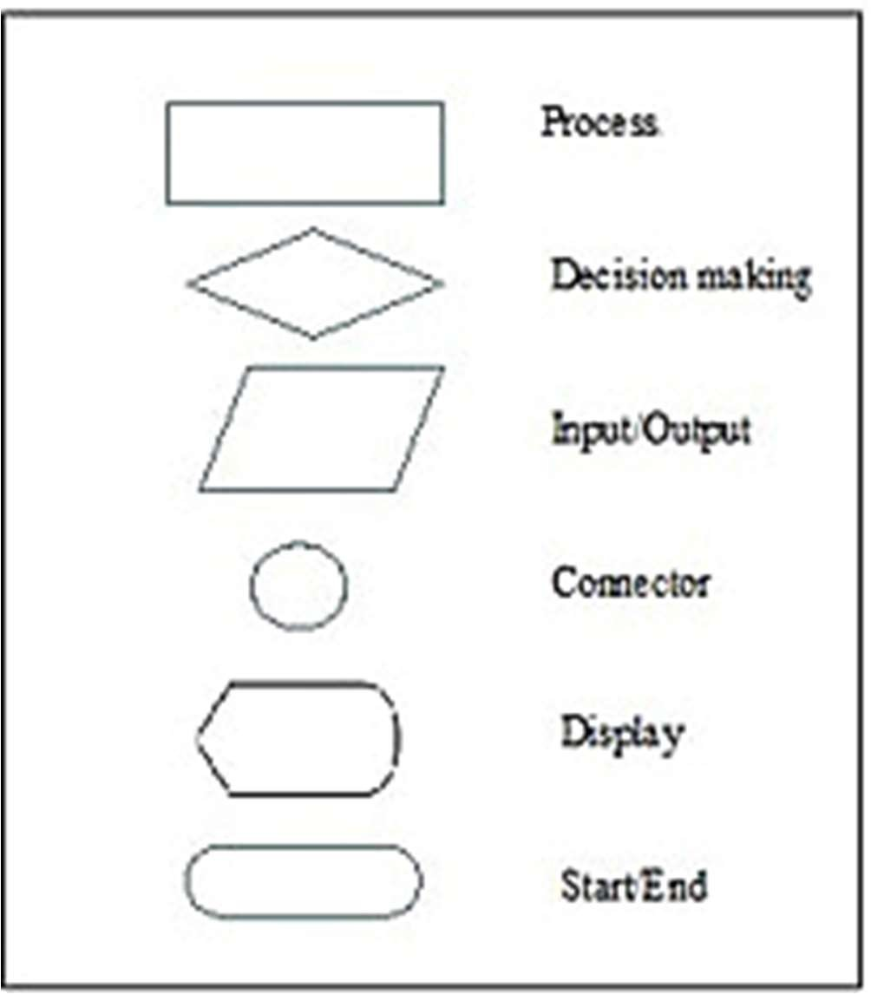


B
HTML/CSS/JS
frontend
Web Server
PHP
File
system
DAS
Back End
Doctor Appointment System

Database Design
The most important aspect of building and application is the design of tables or the database schema. The data stored in the tables must be organized in some manner which is meaningful. The overall objective in the process of table design has been to treat data as an organizational resource and as an integrated whole. The organization of data in a database aim to achieve three major objectives which are given below:
    - Data Integration
    - Data Abstraction
    - Data Independence

Several degrees of normalization have to be applied during the process of table design. The major aim of the process of normalization is to reduce redundancy and the prevent the losing data integrity. Data integrity must be converted at all levels. Pure normalization can access problem related to the storage and retrieval of data. During the process of normalization dependencies can be identified which cause serious problems during deletion and updating. Normalizing also hopes in simplifying the structure of table. The theme behind a database is to handle information as an integrated hole the making access to information easy, quick, inexpensive, and flexible for users. The package depends on how data are maintained in the system each table has been designed with their perfect vision. Minor tables have been treated which through takes much more space facilitates the process of querying fast and accurate

Primary key
A primary key is a unique identifier for each record in a table ensures uniqueness and Data integrity within a single table.

Normalization
Normalization is the process of efficiently organizing data in the database. There are two goals of normalization process: eliminating redundant data (for example storing the same data in more than one table) and ensuring data dependencies make sense (only storing related data in a table). Both are worthy goals as they reduce the amount of space database consumes and ensure that data is logically stored.

First Normal Form (1NF) sets the very basic rules for an organized database:
    - Eliminated duplicate columns from the same table
    - Create separate tables for each group of related data and identify each row with a unique column or set of columns the primary key
Second Normal Form (2NF) father addresses the concept of removing duplicating data:
    - Meet all the requirements of First Normal Form
    - Remove subsets of data that apply to multiple rows of a table and place them in the separate tables
Third normal form (3NF) goes one large step further:
    - Meet all the requirements of second normal form
    - Remove columns that are not dependent upon primary key

DATABASE NAME: hospital

Table 1: admin
to login as admin, patient, or doctor

Field Name | Data Type | Width | Description
id | int | 11 | Id of the login user
username | varchar | 50 | Name of user
password | varchar | 100 | Password of the login user
Primary Key: id

Table 2: users
To store registration details

Field Name | Data Type | Width | Description
id | int | 11 | Id of the user
name | varchar | 100 | Name of user
email | varchar | 100 | Email of the user
password | varchar | 100 | Password of user
address | varchar | 200 | Address of the user
phone | varchar | 20 | Contact details of user
Created_at | timestamp | 20 | Login created at
Primary Key: id

Table 3: appointments
To store appointments booked by the patients and its details

Field Name | Data Type | Width | Description
id | int | 11 | Id of the appointment
user_id | int | 11 | Id of the user
doctor_id | int | 11 | Id of the doctor
appointment_date | date | NA | Date of the appointment
appointment_time | time | NA | Time of the appointment
confirmed_date | date | NA | Date of the confirmed appointment
confirmed_time | time | NA | Time of confirmed appointment
problem | text | 100 | The problems faced by patient
status | varchar | 20 | Status of the appointment
created_at | timestamp | 5 | Time when the appointment was booked
Primary Key: id
Foreign Key: user_id, doctor_id

Table 4: doctors
To store the details of doctors

Field Name | Data Type | Width | Description
id | Int | 11 | Id of the doctor
name | varchar | 100 | Name of the doctor
email | varchar | 100 | Email of doctor
password | varchar | 100 | Password for the doctor
department | varchar | 50 | Department of the doctor
specialization | varchar | 100 | What the doctor specializes in
address | varchar | 100 | Address of doctor
phone | int | 10 | Contact info of doctor
Created_at | timestamp | NA | When account was created
Primary Key: id

Data flow diagram
A data flow diagram is a graphical representation of the flow of data through an information system, modelling its process aspects. A DFD is often used as a preliminary step to create an overview of the system, which can be later elaborated DFD's can also be used for the visualization of data processing. A DFD show so what kind of information will be input to and output from the system, where the data will come from and go to, and where the data will be stored. Four basic symbols are used to construct data flow diagram

It represents a process

It represents data source or destination


It represents data flow

It represents data store

LEVEL 0 DFD
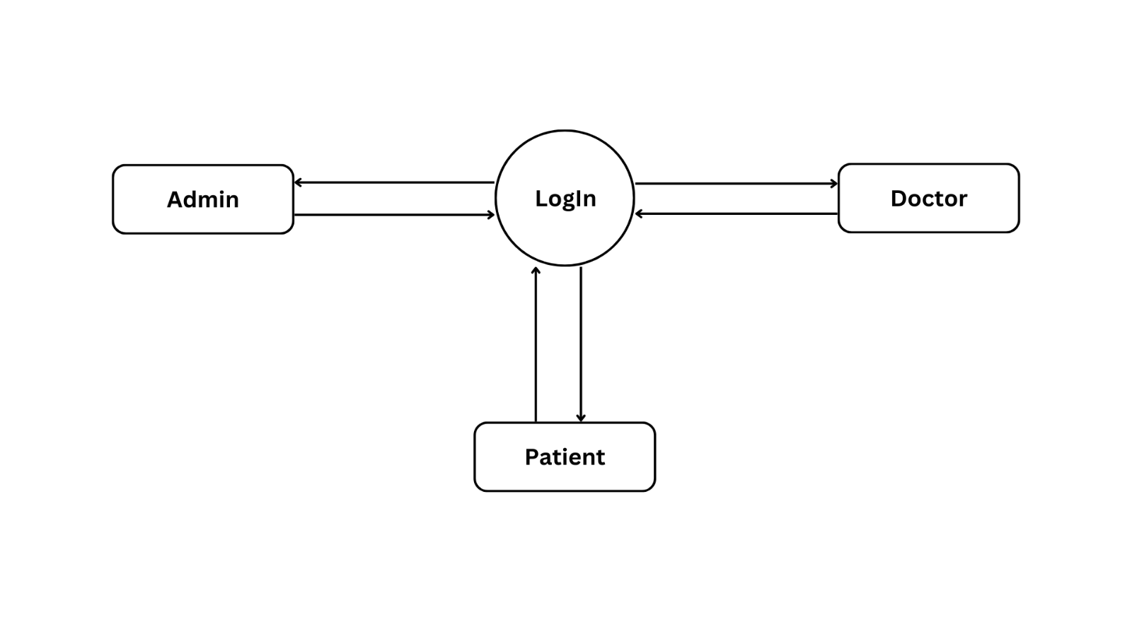

LEVEL 1 DFD ADMIN

LEVEL 1 FOR ADMINISTRATOR

LEVEL 1 FOR PLAYER

Input Design

Patient
USERNAME
ID
PASSWORD
When the patient register and login into the Medicare profile he or she can enter their details into the system and consult a doctor of their preference and can use it any time they wish ;
As the USERNAME and PASSWORD is already recorded by the admin in the database.

Admin
By entering the USERNAME and PASSWORD a doctor as well as patient and an admin can enter, doctors username and password are set by admin. when we are in dashboard there are set of operations such as

Manage doctors
Administrator can add and update a doctors details.

Manage patients
If the administrator needs check whether the patient appointments are updated or not they can use the manage patients

Profile
Doctors and patients can check and update profile

Appointments / my appointments

Appointments booked by patients can be seen

Output Design

Completed
Appointments completed by doctor can be seen

Admin
As administrator knows the doctor and patients that are present in the system

System Development

Introduction
The System Development section outlines the methods, processes, and tools used to build the Doctor Appointment System. The project was developed using a structured approach, ensuring each feature was implemented with clarity and efficiency. The primary focus was to create a seamless user experience for both patients and doctors while maintaining robust functionality.
The development process included:
Requirement analysis for features like appointment booking, updating profiles.
Designing a user-friendly so that the patient can easily book appointment on their preferred time and day.
Testing the application to ensure reliability and accuracy.

Menu Level Description
The project development is to assist the users in minimizing the time and manpower required to manage the online appointment booking system. This project is a modular template system with unique distinction of having a simpler, user-friendly environment. This means that the users do not need any programming knowledge. A set of templates will be defined in the software to create an initial view, she/he can use the simple management interface to control the software and perform their own activities.
The menu contains a dashboard which contains options such as book appointments, to check whether the appointments are approved or not and a profile where both patient and doctor can update their profile.

Process Specification
This section describes the processes involved in achieving the system's functionality such as the “Doctors Appointment System” manages the admin details, patient details as well as the doctors details and the appointment details.
The admin adds details about the doctor and can update their profile, admin can also check the how many appointments are approved or rejected. Patients can register and login and book an appointment and can keep a track of their appointment status. The patients can book an appointment on the preferred time and day.
The doctors can check the appointments of patient and can either approve or reject it. Doctors can even change the time and day of the appointments booked by patients to a suitable one for the appointment.

SYSTEM TESTING

Testing Methods
System Testing of a Doctor Appointment system involves evaluation of entire system to ensure that it meets specified requirements and functions correctly. Here are the key steps and considerations for conducting system testing for quiz game application system:

Functional Testing
Evaluate individual functions to ensure they operated as intended, adhering to specified requirements.

User Interface Testing
Confirm that the interface aligns with design specifications, offering intuitive navigation and effective communication.

Security Testing
Assess the system’s defences against unauthorised access, data breaches, and other potential security risks.

Performance Testing
Identify potential bottlenecks, assess system stability, and optimise performance for optimal functionality

Load Testing
Determine performance under stress, assessing scalability and stability at various stress levels.

Integration Testing
Combine and test individual components or modules to ensure seamless interaction uncovering potential issues

Data Consistency Testing
Validate that information remains accurate and coherent across different components or modules.

Usability and User Experience Testing
Evaluate user interaction, focusing on navigation, efficiency, and error handling. Assess overall satisfaction and emotional response.

Error Handling and Recovery Testing
Assess how well system identifies, reports, and manages errors to prevent data loss or system failure

Scalability Testing
Evaluate the system’s ability to handle an increasing workload, considering performance and resource utilization.

Documentation Review
Evaluate user manuals, help documentation, and training materials for accuracy, completeness, and clarity.

Test Plan Activities
In creation of test plan, several crucial activities are undertaken to ensure the effectiveness of testing process. This begins with clearly defining the scope of testing, identifying specific objectives and goals, and formulating a high-level test strategy. A detailed schedule is then established, allocating resources and setting up the testing environment to mirror the production setting. The development of comprehensive test cases and the preparation of necessary test data follow suit. During the execution phase, defects are meticulously tracked and reported, and stakeholders are regularly updated on testing progress. The criteria for test completion are defined, and conditions for test exit are specified the entire plan is thoroughly reviewed with stakeholders, obtaining the necessary approvals to proceed. These activities collectively contribute to a well-structured test plan that guides the testing team throughout the software development life cycle.

Define Objectives and Scope:
  - Clearly articulate the testing objectives, including the specific functionalities and features to be tested within the doctor appointment system.
  - Define the scope of testing, specifying what is included and excluded from the testing process

Identify Test Deliverables:
  - List the deliverables to be produced during the testing process, such as test cases, test scripts, and test reports.
  - Specify any documentation or artifacts that need to be reviewed during testing, including system requirements and design documents.

Determine Testing Strategy:
  - Decide on the testing levels (unit testing, integration testing, system testing) and types (functional, non-functional) that will be performed.
  - Outline the testing approach including whether manual testing automated testing or a combination of both will be utilized.

Define the Test Environment:
  - Specify the hardware, software, and network configurations required for testing the doctor appointment system.
  - Ensure that the test environment closely resembles the production environment to mimic real world scenarios.

Develop Test Cases:
  - Create detailed test cases covering all aspects of the doctor appointment system, including profile creation, editing access control, and integration with other systems.
  - Include positive and negative test scenarios to thoroughly validate system behavior.

Prioritize Test Cases:
  - Prioritize test cases based on their critically, focusing on high priority functionalities or areas with the potential for high impact on users

Assign Responsibilities:
  - Allocate responsibilities among the testing team members, specifying who will be a responsible for executing specific test cases and tasks

Test Execution:
  - Execute test cases in accordance with the testing strategy and schedule.
  - Record the test results, including any deviations from expected outcomes.

Defect Tracking:
  - Implement a defect tracking system to log to prioritize any issues identified during testing.
  - Provide a clear process for reporting, tracking, and resolving defects

Regression Testing:
  - Conduct regression testing to ensure that a new updates or fixes do not adversely impact previously tested functionalities.
  - Automate regression tests where feasible to streamline the testing process.

Performance testing:
  - Include performance testing activities to assess the system’s responsiveness and scalability under various loads.

25

Screen Layouts
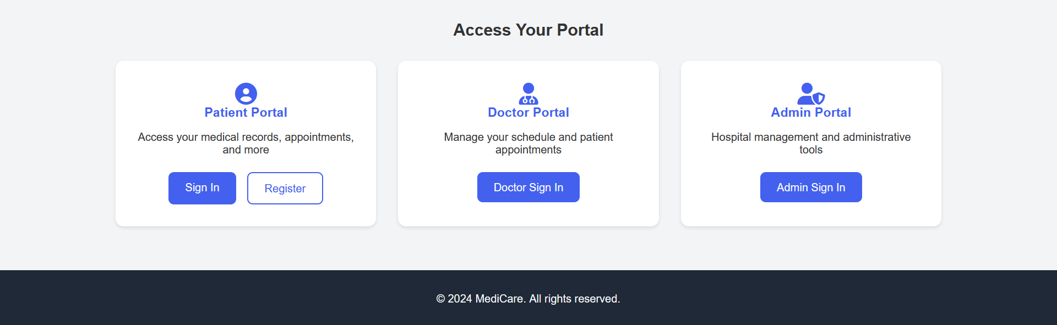
- Home Page
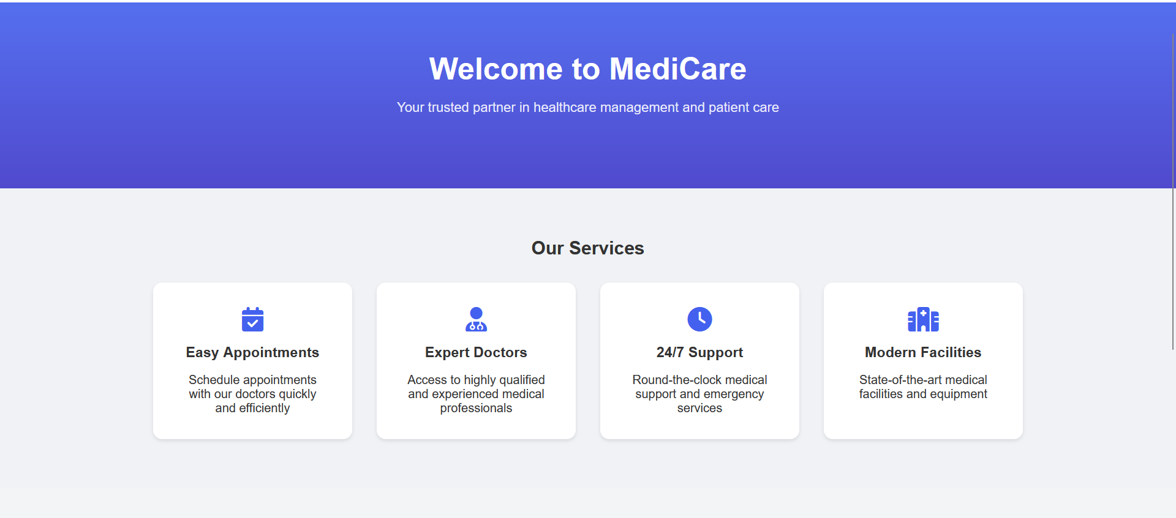
- Admin Login

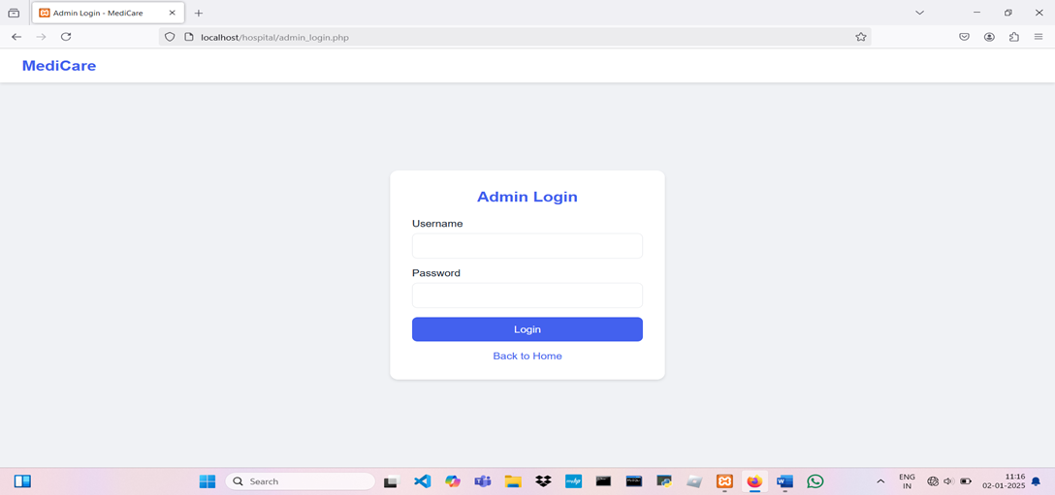

- Admin Dashboard

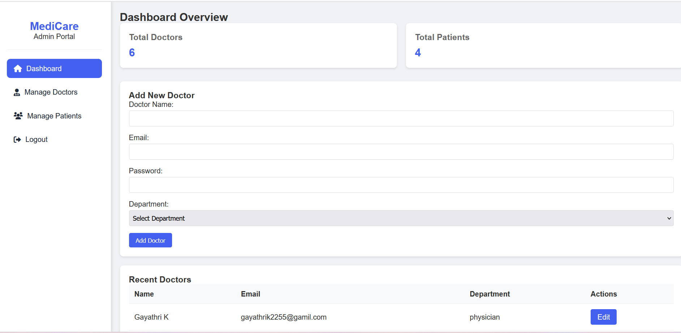

- Admin checking appointment status of patients
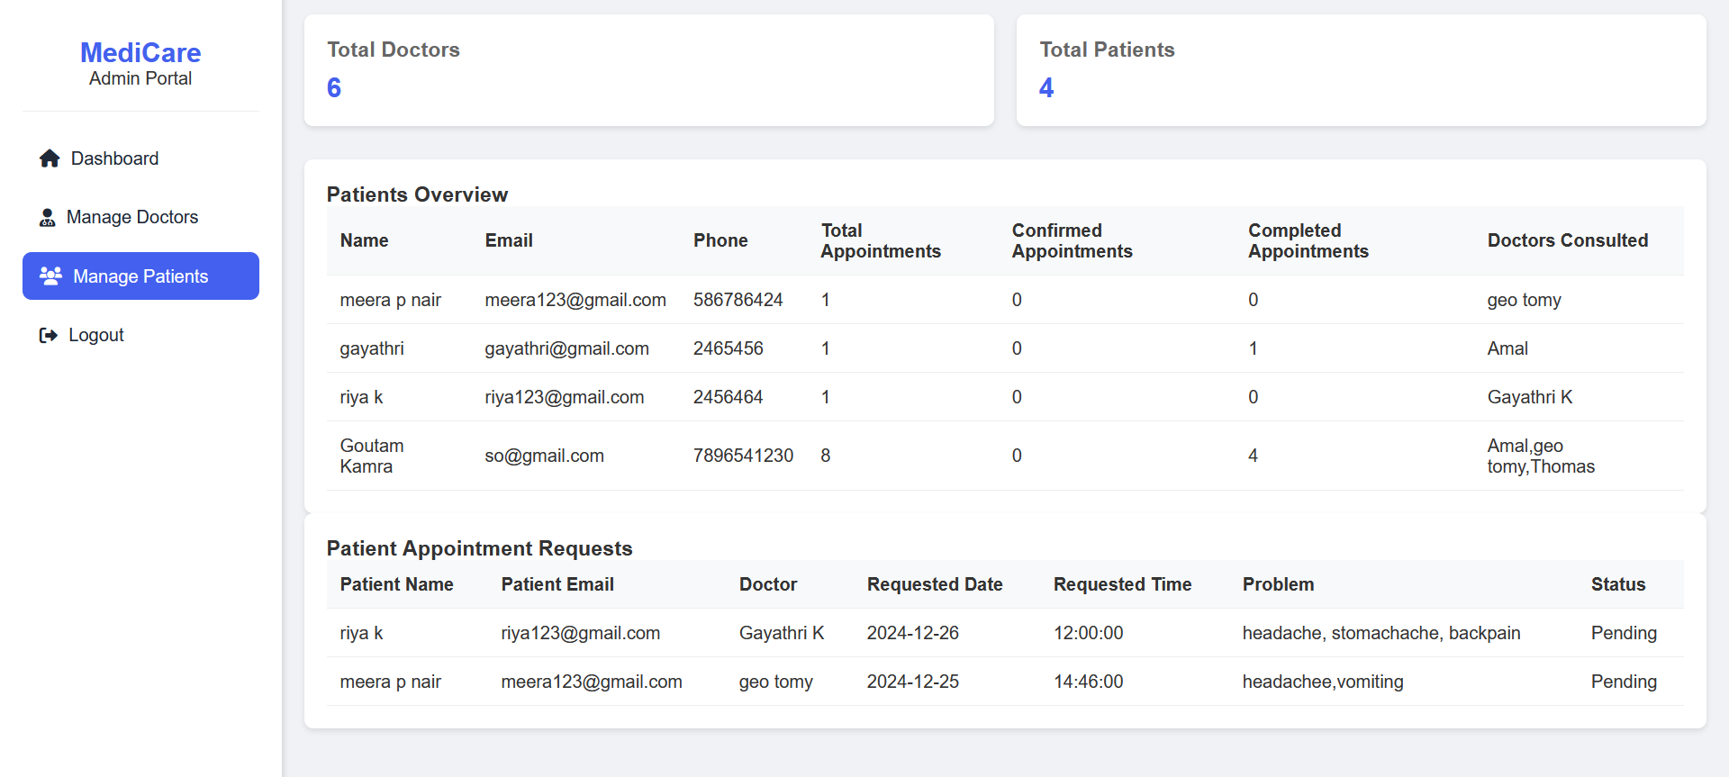

- Doctor Login

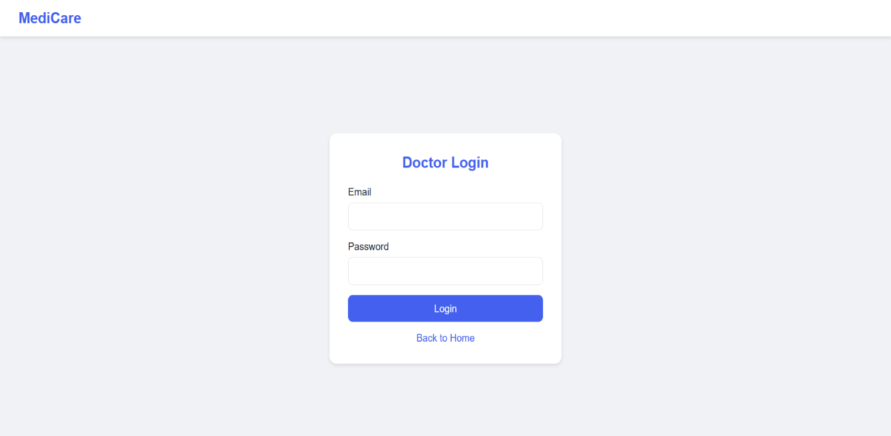

- Doctor Dashboard

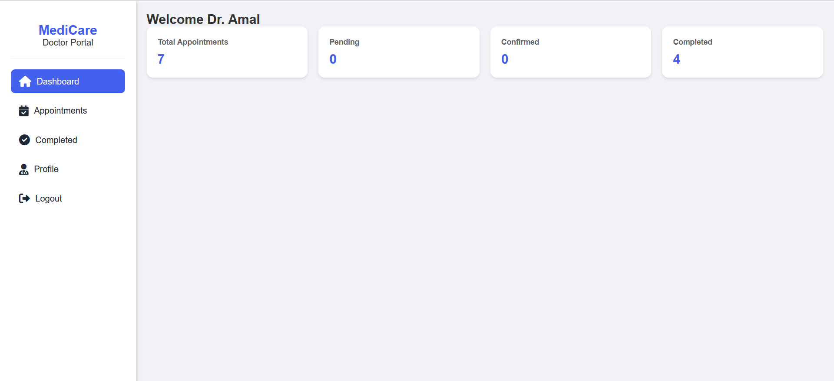

- Appointment section in doctor’s page

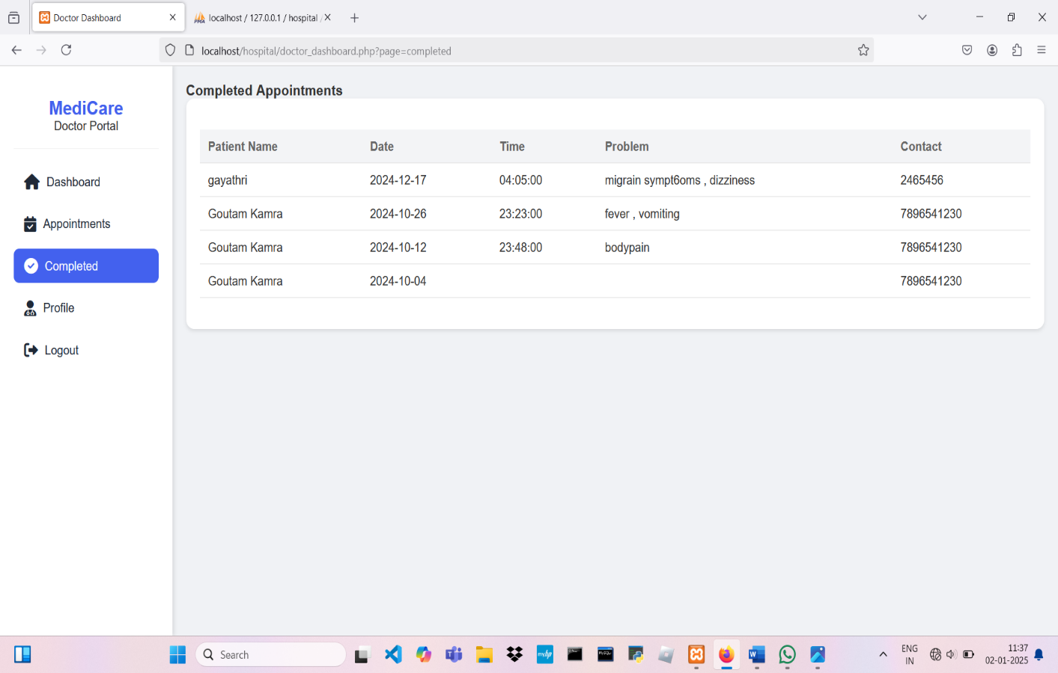

- Doctor profile and doctor can update their profile

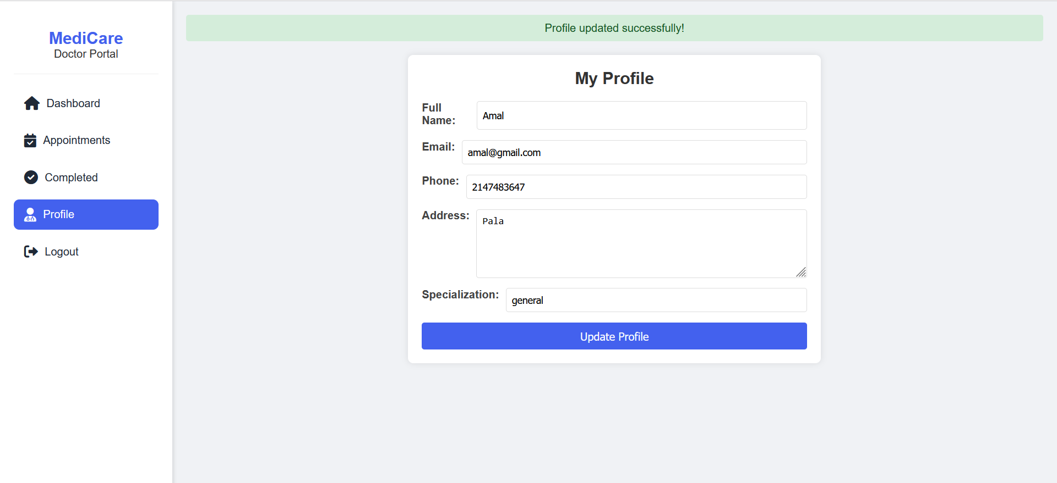

- Current appointments booked by patients in doctor’s page

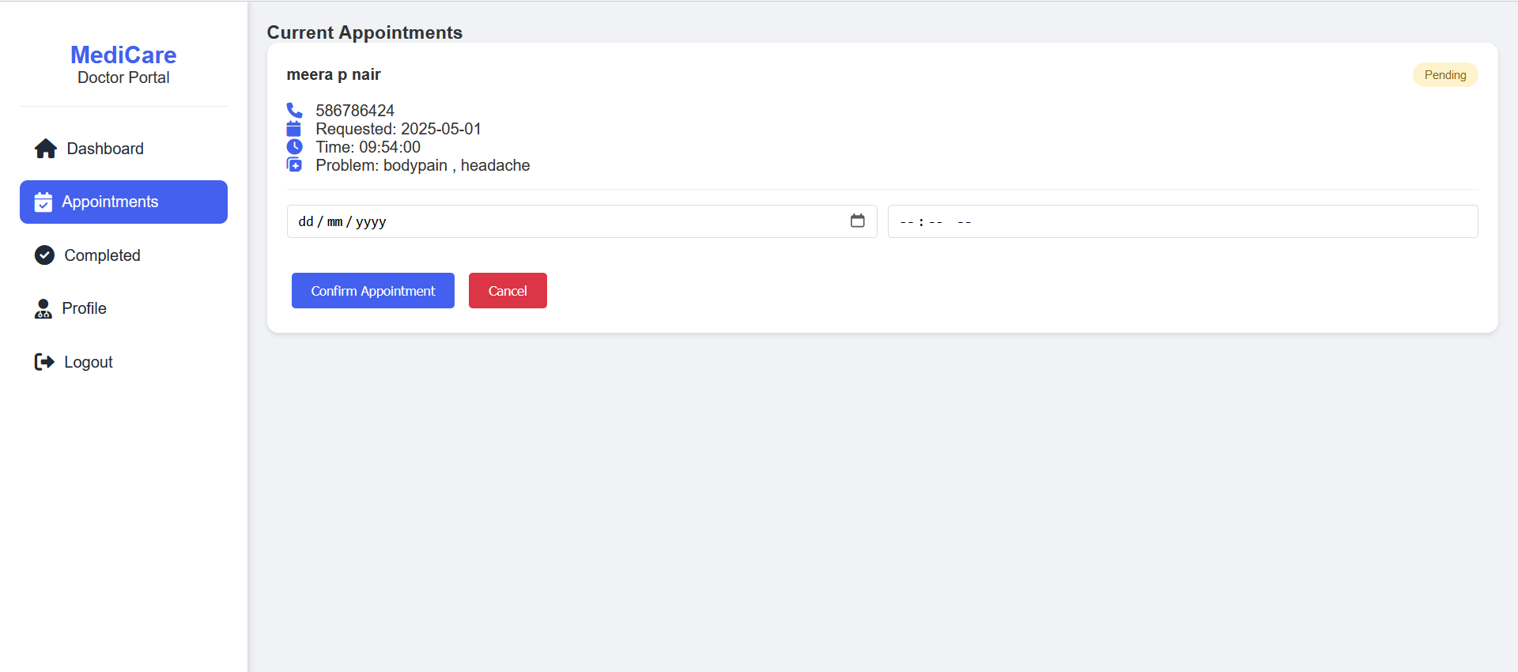

- Patient Login

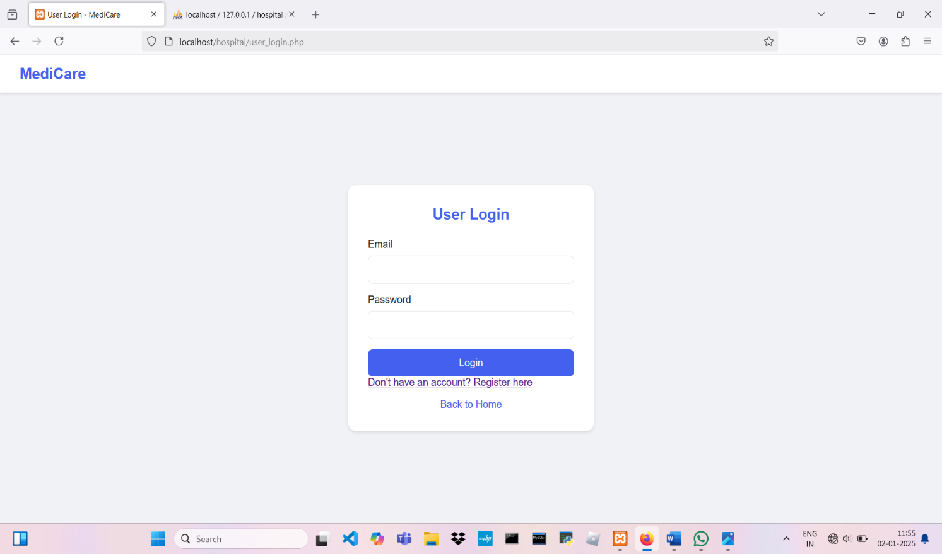

- Patient dashboard

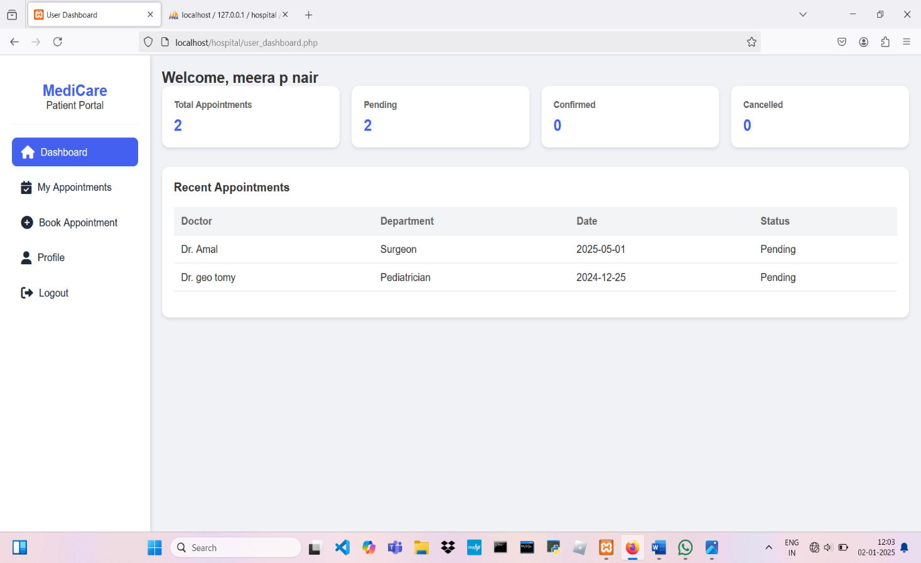

- My Appointments in patient’s page

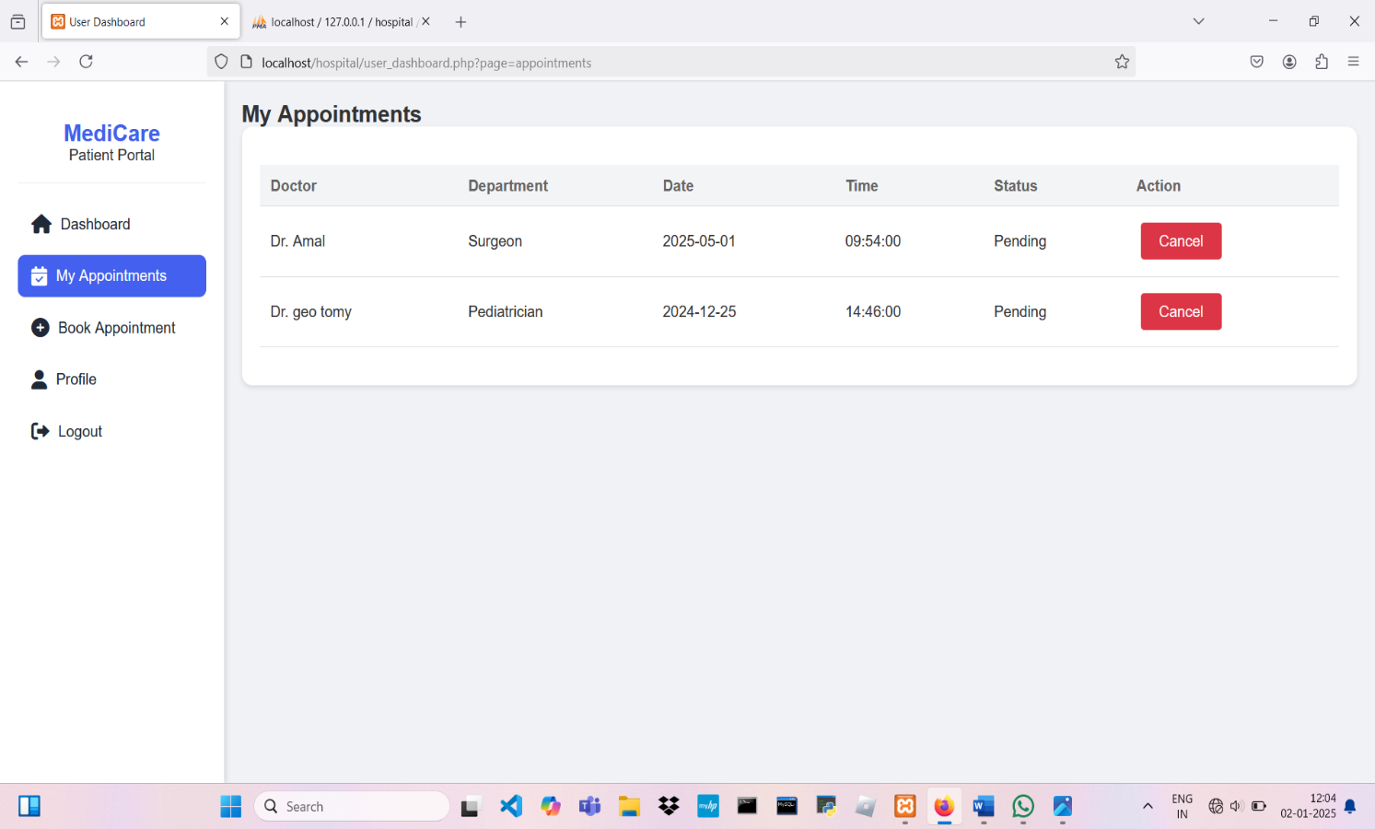

- Patient booking appointment

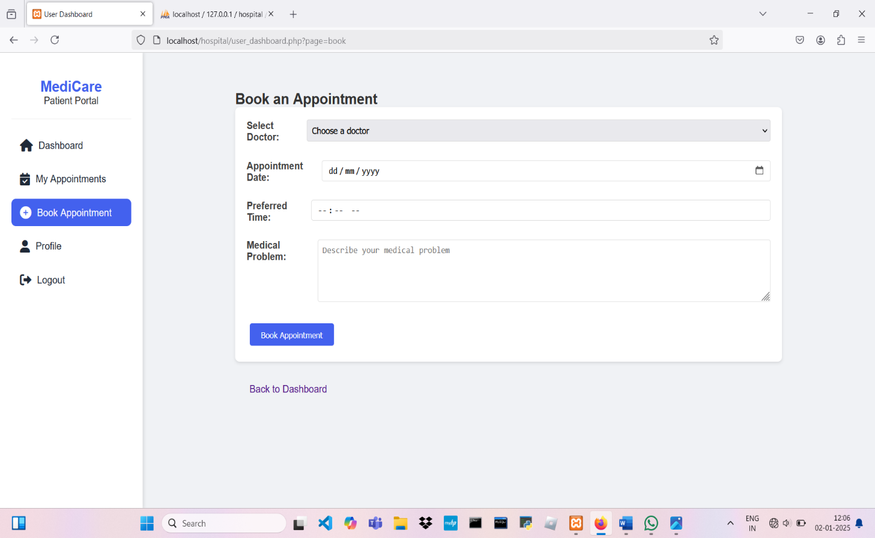

- Patient profile and patient can update their profile

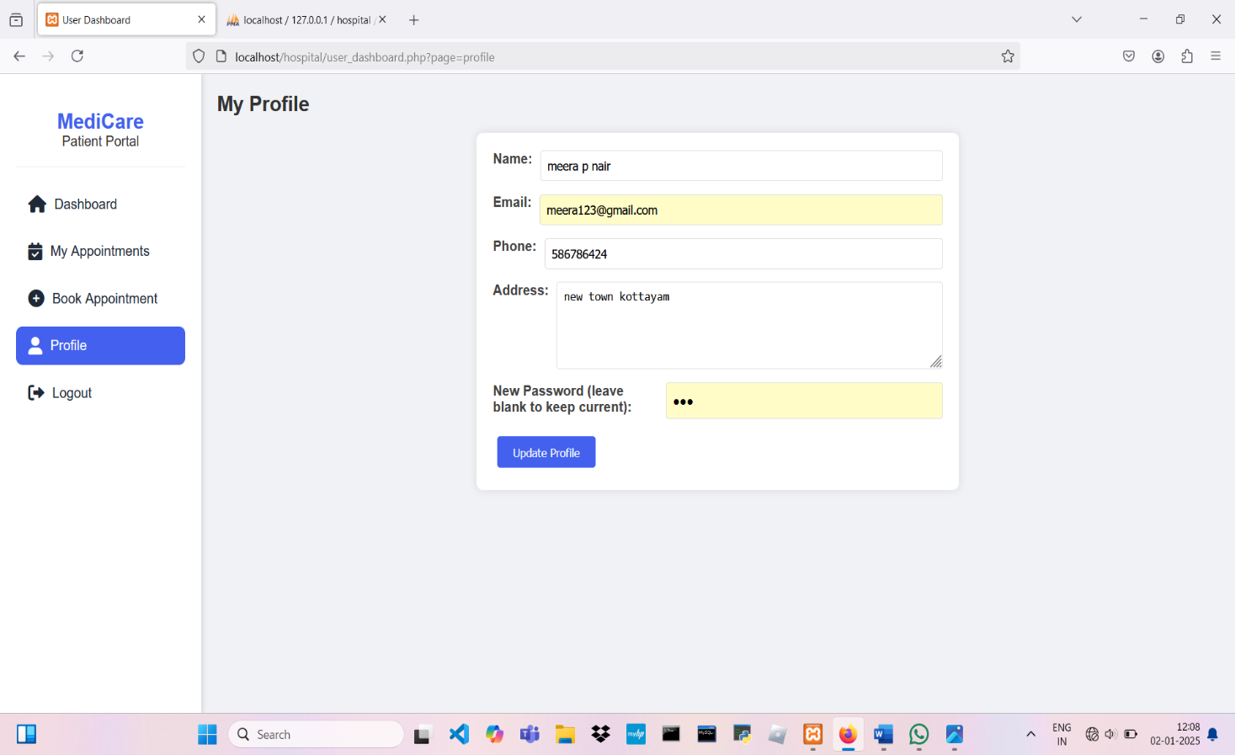

- User registration

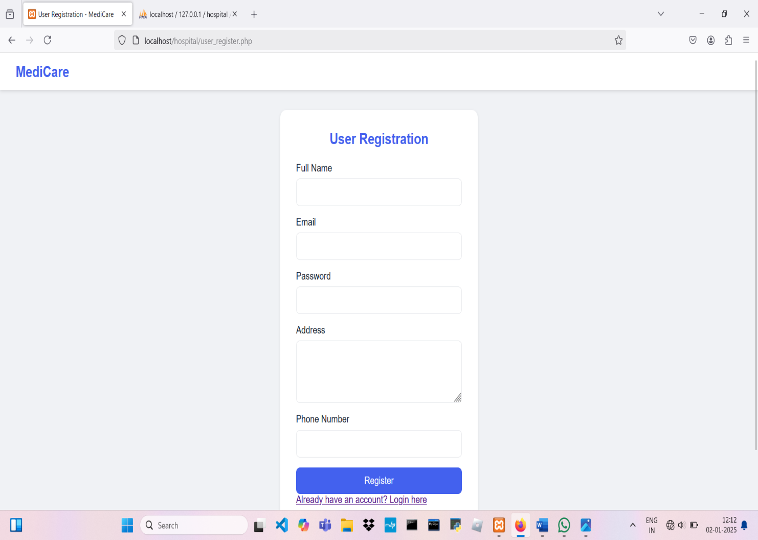

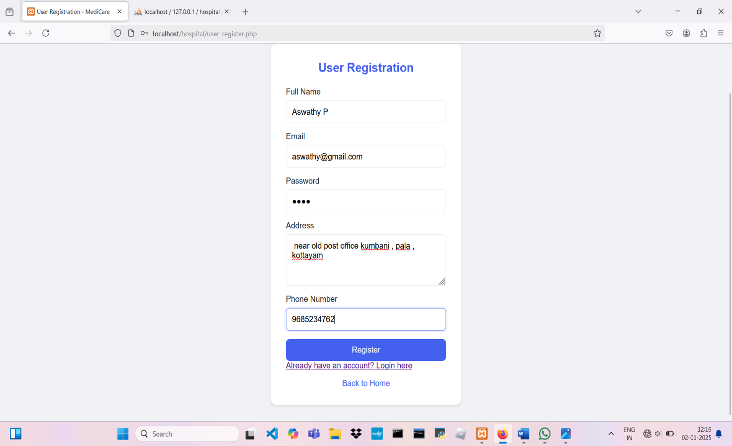

SYSTEM IMPLEMENTATION

System Implementation refers to the process of converting the design and requirements of the quiz project into a fully operational system. The doctor appointment system was developed to provide an informative and engaging experience for players while allowing patient to book appointments efficiently. Below is a simplified outline of the process:

Requirements Analysis:
- Identify the specific requirements for the doctor appointment system, focusing on:
  - Booking appointments efficiently at a preferred time and day.
- Define user roles:
  - Admin: Responsible for creating and updating doctor profile and keeping track of patient appointments.
  - Patients: can book appointments for their preferred doctor and time and day.
  - Doctor: can either accept or reject an appointment and even change it to a suitable time.

System Design:

System Architecture:
  - Design a system that uses a layered approach to separate user interfaces, business logic, and data storage.
  - Use a category-based structure to manage appointments dynamically.

Database Schema:
  - Create tables for:
    - admin
    - patient
    - doctor
    - appointments

User Interface:
  - Design an intuitive interface for patient and doctors:
    - Admin panel for overlooking doctor and patient
    - patient dashboard for booking appointments and seeing their status.
    - Patient can fill in their personal details

Workflow Planning:
  - Define workflows for:
    - Creating profile and booking appointments.
    - Patients book appointments, doctor either approve or reject it and admin overlooks every activity.

Development:
- Use a programming language suitable for application development (e.g., Java for the logic, with a user interface implemented in a framework or desktop GUI).

Develop Appointment Features:
  - Implement appointment booking functionality with dynamic input for specified doctor preferred time and day.
  - Store appointments in a structured database for real-time retrieval.

Develop Patient Features:
  - Allow patient to book appointments, check status, and view appointments immediately.

Develop Doctor Features:
  - Doctor can either reject or accept appointment and change its time and day to a suitable one.
  - Appointments pendings and completed are shown.

Database Implementation:

Database Setup:
  - Create and configure tables to store:
    - appointments, doctors , and patients.
    - Appointment status, timestamps.

Data Management:
  - Design queries to fetch appointments dynamically based on doctors.
  - Save patient login details, responses and appointments with timestamps for tracking .

User Interface Implementation:

Development:
  - Create a user-friendly interface for admin, doctor and patients.
  - Use clear navigation to ensure:
    - Admin can easily add, update doctor and view appointments.
    - Patients can select doctor, view their details, and book appointments seamlessly.

Validation Checks:
  - Include validation mechanisms to:
    - Ensure correct and complete data entry during appointment booking.
Prevent invalid or duplicate responses during appointment booking

Authentication and Access Control:

Secure Authentication:
  - Implement a robust authentication mechanism to verify user identities.
  - Use password-based login for admin, doctor, and patients to ensure security.

Access Control:
  - Set up role-based access controls:
    - Admin can manage doctors and view appointments accepted or rejected.
    - Patients can only access their own profile and their own appointments.
  - Ensure that unauthorized access to restricted sections is blocked.

Testing:

System Testing:
  - Conduct comprehensive testing of all functionalities, including:
    - Appointment booking, booking display, profiles, and doctor profile.
    - User authentication and access restrictions.
  - Validate proper storage and retrieval of data from the database.

Scenario Testing:
  - Test multiple use cases, such as:
    - patient login and registration.
    - Appointments been made correctly to the respective doctors.

Deployment

Application Deployment:
  - Deploy the doctor appointment to a local or server-based environment for operational use.
  - Configure necessary settings for the application to run smoothly, including:
    - Database setup.
    - Application dependencies and configurations.

Production Readiness:
  - Ensure the application is thoroughly tested and optimized before deployment for use.

Documentation Update:

Purpose:
  - Maintain accurate and up-to-date documentation reflecting the system’s development, features, and functionality.

Content Updates:
  - Include details about:
    - New features if any.
    - Adjustments made to existing functionalities (e.g., Realtime appointment status, registration and managing profiles).
    - Steps for resolving common issues faced by users.

Types of Documentation:
  - Technical Documentation:
    - Updated database schema diagrams.
    - Details on code modules and application workflows.

User Documentation:
    - Guides for admin and user to use the current management system.

Testing Documentation:
    - Logs of testing scenarios, results, and fixes for identified issues.

Version Control:
Maintain version control for documentation to track changes

CONCLUSION AND SCOPE FOR FUTURE ENHANCEMENTS
In conclusion, the Doctor Appointment system successfully achieves its goal of providing a seamless platform and has been successfully developed and implemented, providing a convenient and efficient solution for both patient and medical professionals. Key features such as appointment scheduling, automated remainders ,and patients record management have streamlined the appointment process, reduced administrative burdens, improved overall patient satisfaction.it means the patients or users can register and book appointment from anywhere around without need to wait in line for minutes or even hours.

Future Enhancements
Looking ahead, the application offers significant potential for future enhancements. Features such as creating profile and booking an appointment with their preferred doctor at their preferred time and day. The project Doctor Appointment is designed for any future addition to that any user requirements can be made easy. Though the system is working on certain assumption it can be modified easily to any kind of requirements. The design of this software is in such a way that the addition pf any new module is necessary is possible without affecting the integrity of the present system. New features can be added to the software to ensure creditability of the software and easily modified to the adaptable conditions satisfying the users and also based on the latest trend also. New features like,

Appointment remainders and follow ups: implement a robust appointment remainder system, various channels such as SMS, emails or mobile app notifications. Additionally, set up automated follow up messages after appointments to check on patients progress and to provide post -care instructions.

AI_driven Triage system: implement AI driven Triage system to help patients to access the urgency of their medical concerns and recommend appropriate appointment types . It can prioritize patients based on their symptoms and medical history, ensuring urgent cases receive prompt attention.

Electronic health record (EHR) Integration: integrate the appointment system with electronic health records to provide doctors with access to patient’s medical histories, previous diagnose and treatment plans. This can help improve the quality of care and reduce medical errors.

Video conferencing and collaborative tools: enhance telemedicine capabilities by providing secure and user-friendly video conferencing features, along with collaborative tools for doctors to discuss cases and share medical information with colleagues.

Development:

Text Reference:
- Binu M.B and Amaladevi V.C, Web Programming Using PHP, Prakash Publications, Changanacherry, Kerala, 2019
- Bruce Maxim and Roger.S. Pressman, Software Engineering: A practitioners Approach, McGraw Hill Education Publishers, New York, 2009

Web Reference:
- W3Schools: https://www.w3schools.com/ https://www.NareshiTechnologies.com/ https://www.programmingwithmosh.com/ https://www.programizstudios.com/
- ChatGPT

Bootstrap:
https://getbootstrap.com/

